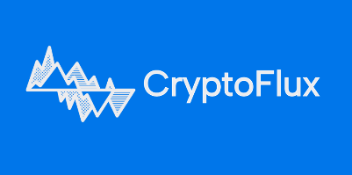

Project Name: CryptoFlux - Crypto Trading Bot
Team: Development Team | Date: Feb 22, 2026

WHAT WENT WELL?  1. Successfully adopted and integrated industry-standard coding practices.  2. Optimized project architecture through comprehensive code refactoring  3. Supervisor feedback was implemented smoothly  4. Achieved timely bug resolution and verification for the v1.0.0 release candidate. | WHAT WENT BAD?  1. The previous coding standards amendment consumed plenty of time  2. Steep learning curve and technical complexity during the architectural pivot.  3. Release timeline impacted by unexpected critical defects in v1.0.0.
WHAT IDEAS DO WE HAVE?  1. Implement periodic architectural audits to prevent technical debt and structural drift.  2. Enforce stricter linting and automated style checks within the CI/CD pipeline. | WHAT WILL WE TRY NEXT?  1. Shift-left on feedback: Mandate peer code reviews for all structural changes at the start of the sprint.

